|  |
| --- |
| sp - VirtualWorld |
| Comp 397 Assignment 3 |
| SlideScroller Game |
| Version #01  All work Copyright © 2012 by SP Games.  All rights reserved. |
| **Sachet Panchal** |
|  |

**300819205**

**Hosted Link**

**http://studentweb.cencol.ca/spanch32/COMP397-MailPilot-master/COMP397-MailPilot/**

|  |
| --- |
| May 29, 2015 |

**Table of Contents**

1. Game Overview
2. Game Play Mechanics
3. Controls
4. Saving and Loading
5. Interface Sketch
6. Script
7. Story Index
8. Art / Multimedia Index
9. Future Features
10. Github link and hosted link
11. **Game Overview**

*Slide Roller is a car game. Drive cautiously by avoiding police coming from opposite sides. Collect fuels in the way to increase your scores.*

1. **Game Play Mechanics**

*Scroll your mouse up and down to control the car. Collect fuels which generates random in the way.*

1. **Controls**

*Use mouse to move up and down.*

1. **Saving and Loading**

*No saving option.*

1. **Interface Sketch**

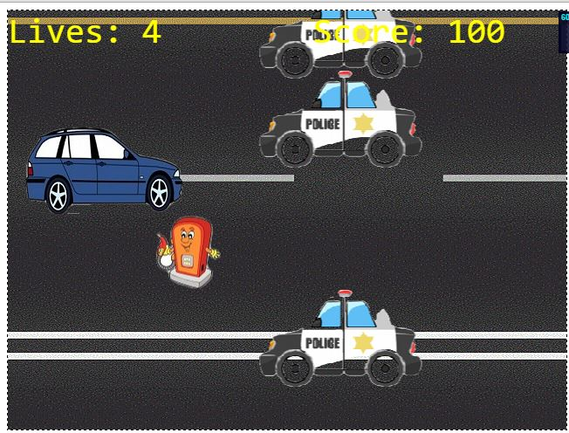

1. **Enemies**

*Police cars coming from right to left.*

1. **Script**

**ImpressJS**

**game.js**

**game.ts**

**game.map.js**

1. **Story Index**

**You need concentration to control your car to avoid police and collect fuels.**

1. **Art / Multimedia Index**

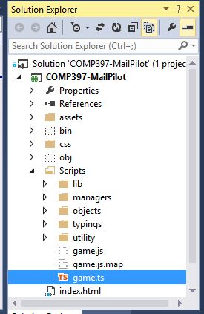

1. **Future Features**

*Pause button, Different types of vehicles to choose.*

*Github version control not working in visual studio.*

**Hosted link**

**http://studentweb.cencol.ca/spanch32/COMP397-MailPilot-master/COMP397-MailPilot/**